Peer Support Volunteer
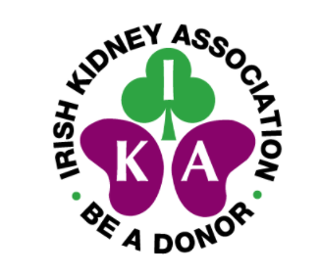
Expression of Interest Form

When completing this Expression of Interest form, please refer to the role description for The Peer Support Volunteer role, which outlines the criteria and required skills to carry out the role satisfactorily.

Peer Details
Name
Address
Postcode
Email address
Contact number
Date of birth
Hospital Attended
Please indicate what motivated you to seek consideration for the role of Peer Support Volunteer

Interests, hobbies, skills
Previous volunteer experience |  |  | List most recent first
 |  |  | Date
 | Where |  | From | To | Role
3

Please tell us what experience and skills you would bring to this role. Include examples and evidence in line with the person specification. Please use additional sheets if required:
Below please tick (√) the relevant boxes that indicate your availability to engage in the role (Up to a maximum of 2 days per week)
 | Monday | Tuesday | Wednesday | Thursday | Friday | Saturday | Sunday
Morning
Afternoon
Evening

Successful applicants for the role of Peer Support Volunteer will be required to be in a position to commit to the role for a minimum of 2 years. Please indicate your ability to commit in line with this . On completion of training volunteers are required to commit to a minimum of 4 hours per week plus one hour for supervision/team meetings. | I can commit |  | I cannot commit

Do you drive/have access to your own transport | Yes |  |  | No
Below please indicate any personal challenges or limitations (e.g., physical) that you consider might impact on your ability to engage fully in the role?

Below please include any additional relevant details to support your expression of interest

Disclosure/declaration
Due to the nature of the work that the Irish Kidney Association is involved with and that our charity primarily deals with vulnerable adults on a day-to-day basis, all those engaged in work on our behalf are required to disclose all criminal convictions. Any offer of the role of Peer Support Volunteer is conditional upon Disclosure and Garda Vetting checks. Please detail any such convictions in the space below. Disclosure of a conviction will not result in automatic exclusion.
Do you have a criminal conviction? If yes, please provide details below: | Yes |  | No

If ‘Yes’ please give details

Declaration
I confirm that the information given above is true and understand that any false or omitted information could lead to my expression of interest being disallowed.

Signed _______________________________ Date __________________________

Sincere thanks for taking the time to complete this expression of interest. Please forward your completed form along with a copy of your most recent C.V. (if you have one), no later than 15th July 2022 to recruitment@ika.ie or by post to the Irish Kidney Association, Donor House, Block 43A, Park West, D12 P5V6.

Following the closing date for receipt of expressions of interest a review of submissions will be undertaken and a shortlist compiled. Shortlisted applicants will be invited for an informal interview in advance of a final decision being reached regarding selection to engage in the service.

